**DSCI 425 – Supervised Learning  
Assignment 1 – Multiple Linear Regression (95 points)**

## Problem 1 – PREDICTING SELLING PRICE OF HOMES IN KING COUNTY, WA

The data for these sales comes from the official public records of home sales in the King County area, Washington State. The data set contains 21,606 homes that sold between May 2014 and May 2015. The table below gives variable names and descriptions. The map below shows the location of all 21,606 homes you will be working with.

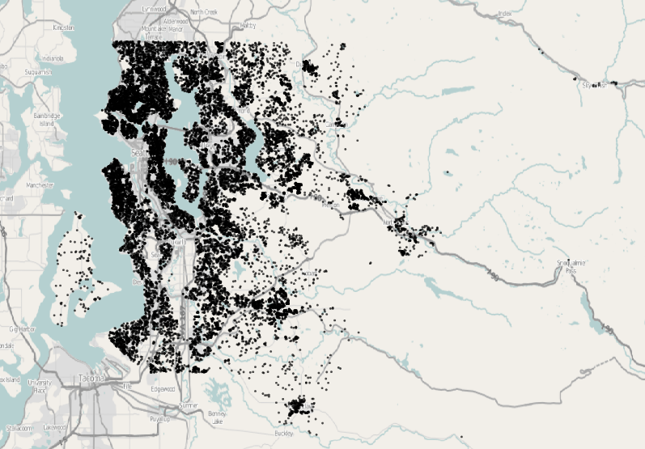

**Variables in King County, WA Datasets**

* **ID – id number (DO NOT USE IN YOUR MODELS!)**
* ****price**** - Price of each home sold
* ****bedrooms**** - Number of bedrooms
* ****bathrooms**** - Number of bathrooms, where .5 accounts for a room with a toilet but no shower.
* ****sqft_living**** - Square footage of the apartments interior living space.
* ****sqft_lot**** - Square footage of the land space.
* ****floors**** - Number of floors.
* ****waterfront**** - A categorical variable for whether the apartment/home was overlooking the waterfront or not (1 = yes, 0 = no).
* ****view**** - An ordinal index from 0 to 4 of how good the view of the property has.
* ****condition**** - An index from 1 to 5 on the condition of the apartment.
* ****grade**** - An ordinal index from 1 to 13, where 1-3 falls short of building construction and design, 7 has an average level of construction and design, and 11-13 have a high quality level of construction and design.  Other intermediary values indicate conditions in between these descriptors.
* ****sqft_above**** - The square footage of the interior housing space that is above ground level.
* ****sqft_basement**** - The square footage of the interior housing space that is below ground level.
* ****yr_built**** - The year the house was initially built.
* ****yr_renovated**** - The year of the house’s last renovation, 0 indicates it has not been renovated.
* ****renovated**** – indicator of whether or not the home has been renovated (1 = yes, 0 = no)
* ****zipcode**** – ZIP code area the house is in (Note: ZIP codes are NOT numeric!)
* ****lat**** - Lattitude of the home
* ****long**** - Longitude of the home
* ****sqft_living15**** - The mean square footage of the interior living space of the nearest fifteen neighboring homes.
* ****sqft_lot15**** - The mean square footage of the land lots of the nearest fifteen neighboring homes.

Develop a regression models using the training data for predicting the selling price of the homes in the test data using the available predictors described above. Note that not all of the variables are numeric and will have to be dealt with accordingly.

> King = read.csv(file.choose()) 🡨 read the file King County Homes (train).csv

> KingTest = read.csv(file.choose()) 🡨 read the file King County Homes (test).csv

Your analysis should be thorough! Document the model development process by copying and pasting relevant R commands, output, and graphics into your write-up. All R code copied and pasted into your final assignment submission MUST be in Courier New 9 point font.

**Tasks**

1. In this part of your analysis of these data you will fit a simple MLR model to these data without trying to address any model deficiencies etc.
2. Fit a base model and discuss any deficiencies (but don’t try to fix them). (10 pts.)
3. Use stepwise reduction of base model to reduce the base model and include discussion of final model. (10 pts.)
4. Use cross-validation methods to estimate the prediction error of this model using split-sample, k-fold, and the .632 bootstrap approaches. (15 pts.)
5. In this part of your analysis of these data, you will develop a MLR that attempts to addresses any deficiencies you identified in part (1) in hopes of ultimately improving predictive performance. Things to consider would be response transformations, and/or adding higher order terms (polynomials terms) and power transformations of the predictors. In the end, I would like you to compare the predictive performance of this model to the one you developed in part (1). Make sure to convert your predictions back to dollars ($).
6. Model development, documentation, and discussion. (20 pts.)
7. Fitting final model, critiquing it, and discussing any deficiencies. (10 pts.)
8. Use cross-validation methods to estimate the prediction error of this model using split-sample, k-fold, and the .632 bootstrap approaches. All prediction measures should be for the response in the ORIGINAL scale, thus you will need to back-transform your predictions in the CV process if you transformed the response. (15 pts.)
9. Give the predicted selling price of the homes in the test data (KingTest) and submit them in a .csv file with your name in it. For example, suppose my final model is called poo.lm then you should do something along the following lines in R.

> mypred = predict(poo.lm,newdata=KingTest)

> submission = data.frame(ID=KingTest$ID,ypred=mypred)

> write.csv(submission,file=”DeppasPredictions.csv”)

Submit the file DeppasPredictions.csv, along with your results from parts (1) and (2) which should be a Microsoft Word document to a D2L dropbox for one of your groups members. Make sure your predicted selling prices are in dollars! (5 pts.)

IMPORTANT NOTE:

Whatever changes you make to the training data MUST also be done to the KingTest data as well. For example, if you choose to log transform the living space variable in the training data, then you must also do this in the test data! If my final model fit to the training data uses the log living space and not living space then when I predict using the test data it must also have log living space as well! The variable names in both datasets (King and KingTest) must be the same!